Key Vocabulary
algorithm | A sequence of ordered instructions. In Scratch, algorithms are referred to as scripts.
block | A puzzle-shaped piece of code. They can connect to other blocks to create algorithms.
code | A set of instructions written in a programming language that a computer can understand.
condition | A block of code that will only run if a certain event is true or false.
loop | A way to repeat a set of instructions over and over again.
sprite | An image that can be created and programmed in Scratch.
variable | A value that can be recorded in the memory of Scratch. A variable can be edited.

What Is Scratch?
Scratch is a free, online program where you can use a coding language to create digital stories, games and animations using characters known as sprites. Scratch uses a visual block-based coding language. Blocks are joined together to create algorithms.
Scratch Interface
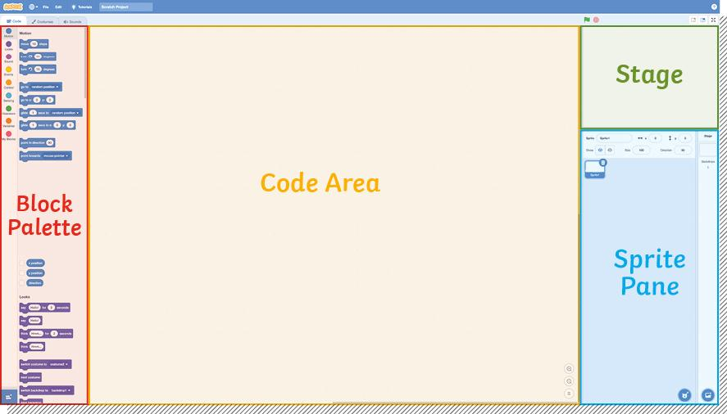

Loops in Scratch
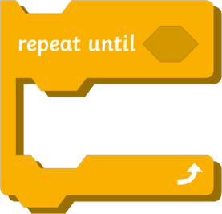
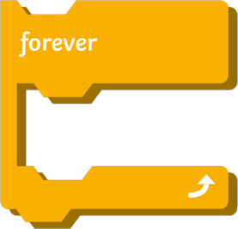
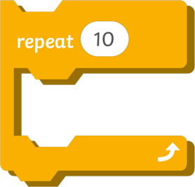
There are three different types of loop blocks in Scratch. They can all be used to repeat a set of instructions but they work in slightly different ways.
The repeat block is a count-controlled block. It can be used to repeat a set of instructions a specific number of times.
The repeat forever block will repeat the instructions inside it without end or until the program is stopped.
The repeat until block is a condition-controlled block. It will repeat the instructions inside it until a certain condition is met.
Decomposition
Decomposition means breaking something down into smaller steps. Decomposing a problem into smaller steps or stages makes it easier to solve the big problem.
Computer programmers and games designers use decomposition all the time in their work.

Debugging

Debugging is the process of testing code and removing any errors or bugs from the program. The term ‘computer bug’ was first used in 1947 by computer scientist Grace Hopper, who discovered that a dead moth in the computer was causing an error.
Why Are Loops Useful?
Loops are a useful way of telling the computer to repeat instructions. They can be used in computer programs to make certain things happen repeatedly. Using loops saves programmers from having to write hundreds or even thousands of lines of code. Loops save time and reduce errors.

